Ubuntu (Dapper Drake 6.06) with Cacti(cacti-0.8.7b.tar.gz) by corbin

Plugin Architecture Install with Syslog-NG Specific Plugin Installation.

Download Ubuntu Server 6.06 LTS at http://www.ubuntu.com/getubuntu/download
Download Cacti from www.cacti.net
Download the Plugin Architecture and the Plugins from http://cactiusers.org/index.php

Good How to Install for Ubuntu… http://www.howtoforge.com/perfect_setup_ubuntu_6.06

Install Ubuntu with ISO - Use the Basic Ubuntu Dapper Drake 6.06 Server Install - First Option – Should go pretty quick with no issue. I installed mine on a VMWARE virtual machine with 2 processors, 3GB Memory, and 20GB Hard Drive.

Set static IP address
vi /etc/networking/interfaces
Remove the dhcp(iface eth0 inet dhcp) setting and add the following lines…

# The primary network interface
auto eth0
iface eth0 inet static
address 192.168.1.2
netmask 255.255.255.0
network 192.168.1.0
broadcast 192.168.1.255
gateway 192.168.1.1

Run command to restart network services for new IP to take effect
# /etc/init.d/networking restart

Run ifconfig to see if changes took effect
# ifconfig

Enable ssh for Putty - http://www.chiark.greenend.org.uk/~sgtatham/putty/download.html
# sudo apt-get install openssh-server openssh-client

Install Apache Web Server with PHP Support
# sudo apt-get install apache2 apache2-common apache2-mpm-prefork apache2-utils
# sudo apt-get install libapache2-mod-php5 php5-cli php5-common php5-cgi

Install mysql server
# sudo apt-get install mysql-server mysql-client libmysqlclient15-dev
# sudo apt-get install php5-mysql

Other Dependencies - some of the dependencies will change in the future - run them separately without the number and it may tell you what the next version available is
# sudo apt-get install make gcc g++
# sudo apt-get install cgilib freetype2 libttf-dev libttf2 libpng12-dev libfreetype6-dev libart-2.0-dev snmp

Allow MySQL Remote Administator to Access Server - int /etc/mysql/my.cnf change the bind-address = 127.0.0.1 to the ip address of the server.

Needed Packages
# sudo apt-get install linux-kernel-headers
# sudo apt-get install build-essential

Install RRD TOOL –
# sudo cd /usr/local/src/
# sudo wget http://tobi.oetiker.ch/~oetiker/webtools/rrdtool/pub/rrdtool-1.2.15.tar.gz
# sudo tar xfvz rrdtool-1.2.15.tar.gz
# sudo cd rrdtool-1.2.15
# sudo ./configure
# sudo make
# sudo make install

This will complete the RRD tool Installation from Source

INSTALL CACTI

Set Directory to work From
# sudo cd /var/www/

Get Latest Cacti Tarball
# sudo wget http://www.cacti.net/downloads/cacti-0.8.7b.tar.gz

Untar the Tarfile
# sudo tar xzvf cacti-0.8.6i.tar.gz

Perform the mv command to rename the directory
# sudo mv cacti-0.8.7b cacti

Change directory to cacti directory
# cd cacti

Create Cacti Database
# sudo myssqladmin -u root create cacti

Import the default Cacti Database
# sudo mysql cacti < cacti.sql

Create a cactiuser
# sudo useradd cactiuser
# passwd cactiuser
# userpassword

Make cactiuser part of www-data group
# sudo usermod -G www-data cactiuser

Change owner ship of /var/www/cacti/rra and /var/www/cacti/log directories
# sudo chown -R cactiuser:www-data rra/ log/

Verify owernship of the rra/ log/ directories - list directories with permissions
# ls -l

Create a mysql username and password for cacti
loginto the mysql server
# sudo mysql --user=root
mysql> GRANT ALL ON cacti.* TO cactiuser@'%' IDENTIFIED BY 'password';
mysql> flush privileges
mysql> exit

Edit the /var/www/cacti/include/config.php to specifiy the mysql user, password and database for your cacti configuration

# vi /var/www/cacti/include/config.php
$database type = "mysql";
$database_default = "cacti";
$database_hostname = "localhost";
$database_username = "cactiuser";
$database_password = "userspassword";
$database_port = "3306";

LOG CRONTAB FOR POSSIBLE TROUBLESHOOTING
# vi /etc/syslog.conf
remove the # comment on the line for the cron log.

the cron log is created in /var/log/cron.log - you may need to restart for this to take effect

CREATE CRONTAB FOR poller.php

switch user to cactiuser
# su cactiuser
# crontab -e

add line to crontab - the 5 represents the minutes between polling... use 1 or 5 for cacti.
*/5 * * * * php /var/www/cacti/poller.php > /dev/null 2>&1

LOG INTO CACTI SERVER –
I had to restart before the following screens would show up.
http://yourservername/cacti

and you’ll see this screen… click next

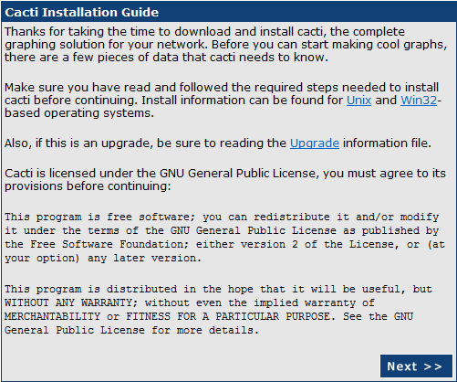

Click next if you have a new install…

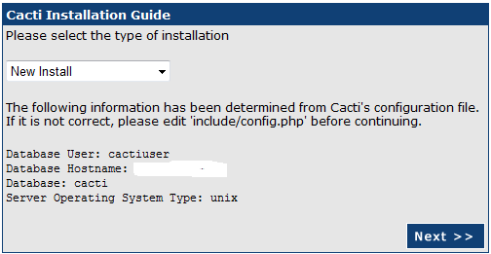

Make sure the RRDTOOL Binary Path Matches for Ubuntu dapper 6.06 it is /usr/local/rrdtool-1.2.15/bin/rrdtool - 1.2.15 is the version of rrdtool which may vary.

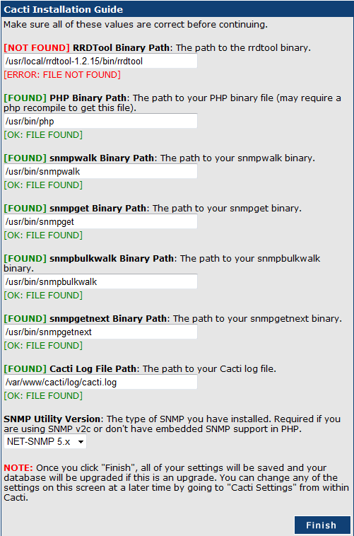

Default username and password – admin/admin

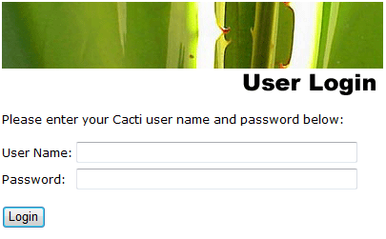

It will force a password change…

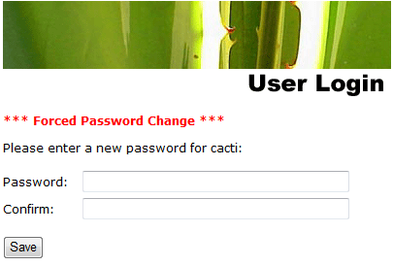

*A couple of Settings to Verify... Under the Settings/General Tab the Default RRDTool Utility Version is listed as RRDTool 1.0.x. It needs to be changed to RRDTool 1.2.x. Graphs will not work unless you do this.

*For me there is a bug when trying to add the Alternate Poller Path /Spine Poller Path under the Settings/Path Tab. When the /var/www/cacti/poller.php file is added there it does not seem to run so I did not enter it. I left the poller type under the Settings/Poller Tab as cmd.php even though I have the poller.php file in the crontab.

PLUGIN ARCHITECTURE INSTALL – Before you start Backup you Cacti Install
The Following is a summary of
http://cactiusers.org/wiki/PluginArchitectureInstall

Make a Backup Directory
#sudo mkdir /tmp/Cacti_Backup
Backup your cacti Install
#sudo cp –r /var/www/cacti /tmp/Cacti_Backup

Download the Plugin Architecture and the Plugins… www.cactiusers.org
*I did this in windows and used winscp to copy the files to the Ubuntu install. I created a downloads directory under root to copy the Plugins Architecture and Plugins into.
Winscp - http://winscp.net/eng/index.php

Make Sure the Patch command will work for the Plugin Architecture Install to Work.
Install the build-essential
#sudo aptitude install build-essential

Extract the Tar File
#sudo tar -zvxf cacti-plugin-arch.tar.gz

Copy the cacti*.diff file in the plugin-arch directory to the cacti install directory
#sudo cp cacti-plugin-0.8.7b-PA-v2.0.diff /var/www/cacti

Run the Patch Command from the Cacti Directory to see if there are any errors.
# sudo patch -p1 -N --dry-run < cacti-plugin-0.8.7b-PA-v2.0.diff

If all goes well then Run the Patch
# sudo patch -p1 -N < cacti-plugin-0.8.7b-PA-v2.0.diff

PLUGINS

Most of the Plugins can e installed by following the directions on the cacti user site.

http://cactiusers.org/wiki/Homepage

http://cactiusers.org/wiki/PluginsInstall

The Plugins are fairly easy to install depending on which one you are doing. Here are just a few things that might help the install.

You will first need to extract the files and add/copy them to the /var/www/cacti/plugins directory. Each plugin will have its own folder.
Example... SETTINGS will be… /var/www/cacti/plugins/settings
THOLD will be… /var/www/cacti/plugins/thold
MONITOR will be… /var/www/cacti/plugins/monitor

Then the /var/www/cacti/include/config.php file will need edited with the plugins to be activated.
#sudo vi /var/www/cacti/include/config.php

Add the lines to the bottom of the file. The top line must be first and settings should be before thold in order for it to fully function according to the thold documentation. Other desired plugins will follow.
$plugins = array();
$plugins[] = ‘settings’;
$plugins[] = 'thold';
$plugins[] = 'monitor';
$plugins[] = 'discovery';
$plugins[] = ‘syslog’;

Here is an example of the /var/www/cacti/include/config.php log file with the plugins activated.

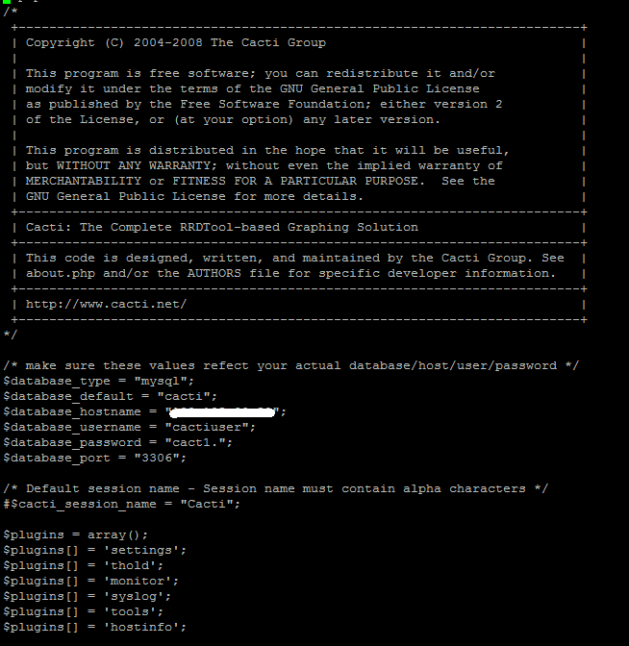
ACTIVATE SQL TABLES FOR PLUGINS

After Activating the Plugins go into the user management and click on the Admin user. There will be some additional items under realm permissions that you will need to check for the tabs to show up.

Some plugins come with a .sql file. Add the tables in this file to mysql with the following command.
#sudo mysql cacti < filename.sql
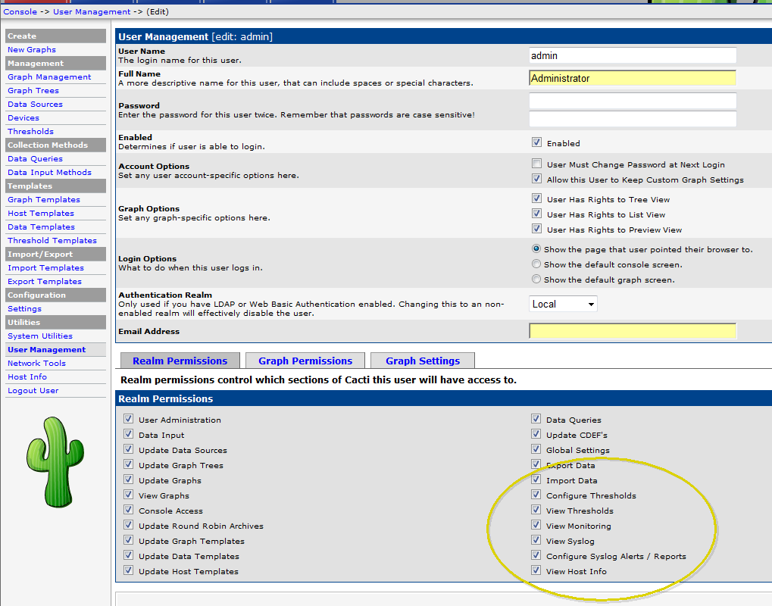

SYSLOG PLUGIN INSTALL
Download the latest Syslog plugin 0.5.2
Unpack it and Copy it to the /var/www/cacti/plugin directory.

Create a Syslog Database
# sudo mysqladmin -u root create syslog
# sudo mysql –u root
mysql>GRANT ALL ON syslog.* TO cactiuser@'%' IDENTIFIED BY 'password';
mysql> GRANT ALL ON syslog.* TO cactiuser@localhost IDENTIFIED BY 'password';

Import /var/www/cacti/plugin/syslog/syslog.sql file to new syslog database
#sudo mysql syslog < /var/www/cacti/plugin/syslog/sylog.sql

Edit the following lines of /var/www/cacti/plugin/syslog/config.php to match the credentials that were entered.

$syslogdb_type = 'mysql';
$syslogdb_default = 'syslog';
$syslogdb_hostname = 'localhost';
$syslogdb_username = 'cactiuser';
$syslogdb_password = 'CactiMadeEZ';

Don’t forget to add syslog to the /var/www/cacti/include/config.php file.

INSTALL SYSLOG-NG to Integrate with Cacti Syslog
A couple of good web sites for helping with this process
http://www.debianhelp.co.uk/syslog-ng.htm
http://wiki.engardelinux.org/index.php/HOWTO:Installing_syslog-ng
In order to use apt-get to install syslog-ng edit /etc/apt/sources.list and uncomment all the deb-src and deb http locations then run apt-get update.
Install Syslog-NG
# sudo apt-get install syslog-ng
Answer yes to overwrite files and install.

This seems to be the best process for Telling Syslog-NG to Write to MySQL but it is for FreeBSD6.2 I have modified paths to match Ubuntu. http://www.nmsworld.com/UNIX/Syslog-NG.htm

Make a Backup copy and then edit the syslog-ng.conf file
# sudo cp /etc/syslog-ng/syslog-ng.conf /etc/syslog-ng.conf.old
# sudo vi /etc/syslog-ng/syslog-ng.conf

Add this snippet to the bottom of the destinations section in the syslog-ng.conf file…
------------------------------------
# SQL
destination d_mysql { pipe("/var/log/mysql.pipe" template("INSERT INTO syslog_incoming (host, date, time, message, priority, facility) VALUES ( '$HOST', '$YEAR-$MONTH-$DAY', '$HOUR:$MIN:$SEC', '$MSG', '$PRIORITY', '$FACILITY' );\n") template-escape(yes)); };
------------------------------------
Add this snippet to the logs section in the syslog-ng.conf file… the s_all portion of this snippet is defined under the sources section of the syslog-ng.conf file.
---------------------------------------
# mysql log
log { source(s_all); destination(d_mysql); };
---------------------------------------

I made the source section looks like this in order to only log received udp packets.
---------------------------------------
######
# sources

# all known message sources
source s_all {
# message generated by Syslog-NG
# internal();
# standard Linux log source (this is the default place for the syslog()
# function to send logs to)
# unix-stream("/dev/log");
# messages from the kernel
# file("/proc/kmsg" log_prefix("kernel: "));
# use the following line if you want to receive remote UDP logging messages
# (this is equivalent to the "-r" syslogd flag)
udp();
};
----------------------------------------
Now Create the mysql.pipe…
# sudo mkfifo /var/log/mysql.pipe

Restart the syslog-ng services
# /etc/init.d/syslog-ng restart
# /etc/init.d/sysklogd restart

Create a script to pipe syslog-ng to mysql.
# vi /var/www/cacti/plugins/syslog/syslog-ng-to-mysql.sh

Add this snippet to it. Don’t forget to change the cactiuser and cactipassword to match your environment.

-----------------------------------------
#!/bin/bash

if [ -e /var/log/mysql.pipe ]; then
while [ -e /var/log/mysql.pipe ]
do
/usr/bin/mysql -u cactiuser --password=cactipassword syslog < /var/log/mysql.pipe
done
else
mkfifo /var/log/mysql.pipe
fi
-----------------------------------------

Now make the script executable.
# chmod a+x /var/www/cacti/plugins/syslog/syslog-ng-to-mysql.sh

Run the script and the syslog messages should show up in the database and in the cacti syslog tab. The & allows it to run in the background.
# /var/www/cacti/plugins/syslog/syslog-ng-to-mysql.sh &

Create a Startup Script so logging starts after a reboot.
#vi /etc/init.d/syslog-ng-fifo-mysql.sh

Enter in this snippet…

---------------------------------------
#!/bin/sh

echo -n " Syslog-NG FIFO MySQL Logging"
case "$1" in

start)
/var/www/cacti/plugins/syslog/syslog-ng-to-mysql.sh &
;;
stop)
;;
*)
echo ""
echo "Usage: `basename $0` {start}" >&2
exit 64
;;

esac

exit 0
---------------------------------------

Make the script executable.
# chmod a+x /etc/init.d/syslog-ng-fifo-mysql.sh

Update the rd.d to run script at bootup.
# update-rc.d /etc/syslog/init.d/syslog-ng-fifo-mysql.sh defaults

